“Government Info Bot: Your One-Stop Government Loan and Insurance Scheme Advisor”

## A PROJECT REPORT

***Submitted by,***

| Mr. NAVEEN R | - 20201CAI0163 |
| --- | --- |
| Mr. KARTHIK K R | - 20201CAI0185 |
| Mr. VIKAS N M | - 20201CAI0193 |
| Mr. MANOJ KUMAR R | - 20201CAI0207 |

### *Under the guidance of,*

**Dr. SWATI SHARMA**

***in partial fulfillment for the award of the degree of***

**BACHELOR OF TECHNOLOGY**

**IN**

**COMPUTER SCIENCE AND ENGINEERING,**

**(Artificial Intelligence and Machine Learning)**

**At**



**PRESIDENCY UNIVERSITY**

**BENGALURU**

**JANUARY 2024**

**PRESIDENCY UNIVERSITY**

**SCHOOL OF COMPUTER SCIENCE ENGINEERING**

**CERTIFICATE**

This is to certify that the Project report **“Government Info Bot: Your One-Stop Government Loan and Insurance Scheme Advisor”** being submitted by “**NAVEEN R, KARTHIK K R, VIKAS N M, MANOJ KUMAR R**” bearing roll number(s) “**20201CAI0163, 20201CAI0185, 20201CAI0193, 20201CAI0207**” in partial fulfillment of requirement for the award of degree of Bachelor of Technology in Computer Science and Engineering - Artificial Intelligence and Machine Learning is a bonafide work carried out under my supervision.

| **Dr. Swati Sharma**  Asst. Professor  School of CSE&IS  Presidency University | **Dr. Zafar Ali Khan**  Asst. Professor,HOD  School of CSE&IS  Presidency University |
| --- | --- |

| **Dr. C. KALAIARASAN**  Associate Dean  School of CSE&IS  Presidency University | **Dr. L. SHAKKEERA**  Associate Dean  School of CSE&IS  Presidency University | **Dr. SAMEERUDDIN KHAN** Dean  School of CSE&IS  Presidency University |
| --- | --- | --- |

**PRESIDENCY UNIVERSITY**

**SCHOOL OF COMPUTER SCIENCE ENGINEERING**

**DECLARATION**

We hereby declare that the work, which is being presented in the project report entitled **“Government Info Bot: Your One-Stop Government Loan and Insurance Scheme Advisor”** in partial fulfillment for the award of Degree of **Bachelor of Technology** in **Computer Science and Engineering(Artificial Intelligence and Machine Learning)**, is a record of our own investigations carried under the guidance of **Dr.Swati Sharma,Asst.Professor,** **School of Computer Science Engineering Presidency University, Bengaluru.**

We have not submitted the matter presented in this report anywhere for the award of any other Degree.

|  | **Vikas N M(20201CAI0193)**  **Manoj Kumar R(20201CAI0207)**  **Karthik K R(20201CAI0185)**  **Naveen R(20201CAI0163)** |
| --- | --- |

**ABSTRACT**

Government InfoBot emerges as an innovative solution in the field of artificial intelligence, dedicated to providing comprehensive guidance on government-sponsored loans and insurance schemes. Developed with advanced technologies, including Neural Machine Translation (NMT) and implemented on the TensorFlow framework using Python, Government InfoBot streamlines access to crucial information from diverse government sources. The chatbot's primary mission is to dispel uncertainties surrounding government financial programs, offering personalized recommendations and simplifying the intricate application process.

The overarching goal is to promote transparency and enable users to make well-informed decisions about their financial choices. The chatbot's capabilities extend beyond information provision, offering users step-by-step guidance throughout the entire life cycle of a loan application, from initial inquiry to fund disbursement.

Moreover, Government Info Bot ensures a seamless user experience with round-the-clock accessibility from any location, enhancing user convenience and engagement. This abstract positions Government Info Bot as an advanced tool, seamlessly integrating artificial intelligence into the public information assistance domain.   
  
The ultimate objective is to empower individuals by simplifying their interaction with government-sponsored financial offerings, fostering awareness, and facilitating informed decision-making.

**ACKNOWLEDGEMENT**

First of all, we indebted to the **GOD ALMIGHTY** for giving me an opportunity to excel in our efforts to complete this project on time.

We express our sincere thanks to our respected dean **Dr. Md. Sameeruddin Khan**, Dean, School of Computer Science Engineering & Information Science, Presidency University for getting us permission to undergo the project.

We record our heartfelt gratitude to our beloved Associate Deans **Dr. C. Kalaiarasan and Dr. Shakkeera L,** School of Computer Science and Engineering(Artificial Intelligence and Machine Learning), Presidency University for rendering timely help for the successful completion of this project.

We are greatly indebted to our guide **Dr. Swati Sharma, Asst. Professor** School of Computer Science and Engineering (Artificial Intelligence and Machine Learning), Presidency University for her inspirational guidance, valuable suggestions and providing us a chance to express our technical capabilities in every respect for the completion of the project work.

We would like to convey our gratitude and heartfelt thanks to the University Project-II Coordinators **Dr. Sanjeev P Kaulgud, Dr. Mrutyunjaya MS** and also the department Project Coordinators **Dr. Mulari Paremeswaran**.

We thank our family and friends for the strong support and inspiration they have provided us in bringing out this project.

| **VIKAS N M** |
| --- |
| **K R KARTHIK** |
| **MANOJ KUMAR K** |
| **NAVEEN R** |

**LIST OF TABLES**

| **Sl. No.** | **Table Name** | **Table Caption** | **Page No.** |
| --- | --- | --- | --- |
| 1 | Table 1 | GANTT CHART | 43 |

**LIST OF FIGURES**

| **Sl. No.** | **Figure Name** | **Caption** | **Page No.** |
| --- | --- | --- | --- |
| 1 | Figure 1 | Role of NMT in chatbot | 2 |
| 2 | Figure 2 | Learning mechanism of chatbot | 3 |
| 3 | Figure 3 | Chatbot as User friendly | 5 |
| 4 | Figure 4 | For this chatbot accessibility (24*7) | 6 |
| 5 | Figure 5 | For this chatbot architecture | 26 |
| 6 | Figure 6 | And dialog flow of chatbot | 27 |
| 7 | Figure 7 | Objectives (advantage)of chatbot | 29 |
| 8 | Figure 8 | Chatbot Processing | 30 |
| 9 | Figure 9 | Benefits of chatbot for customers | 34 |

**TABLE OF CONTENTS**

| **CHAPTER NO.** | **TITLE** | **PAGE NO.** |
| --- | --- | --- |
|  | **COVER PAGE**  **CERTIFICATE**  **DECLARATION**  **ABSTRACT**  **ACKNOWLEDGMENT** | **i**  **ii**  **iii**  **iv**  **v** |
| **1** | **INTRODUCTION** |  |
|  | 1.1 The Role of Neural Machine Translation (NMT) | 1 |
|  | 1.2 Gov-Info Bot's Learning Mechanism | 2 |
|  | 2. Enhancing User Experience |  |
|  | 2.1. Personalized Recommendations: | 3 |
|  | 2.2 Transparent Information Delivery: | 4 |
|  | 2.3 User-Friendly Guidance: | 4 |
|  | 3: Accessibility Anytime, Anywhere | 5 |
| **2** | **LITERATURE REVIEW** | **7** |
| **3** | **RESEARCH GAPS OF EXISTING METHODS** | **18** |
| **4** | **PROPOSED METHODOLOGY** | **22** |
| **5** | **ARCHITECTURE AND DIAGRAM** | **26** |
| **6** | **SYSTEM DESIGN AND IMPLEMENTATION** | **30** |
|  | 6.1 Components | 31 |
|  | 6.2 Modules | 32 |
|  | 6.3 Interfaces | 33 |
|  | 6.4 Data | 34 |
|  | **IMPLEMENTATION** |  |
|  | 6.5 Neural Machine Translation (NMT). | 35 |
|  | 6.6 Learning Mechanism with Recurrent Neural Networks (RNNs) | 37 |
|  | 6.7 TensorFlow Framework and Python | 39 |
| **7** | **TIMELINE FOR EXECUTION OF PROJECT** | **41** |
| **8** | **OUTCOMES** | **44** |
| **9** | **RESULTS AND DISCUSSIONS** | **47** |
| **10** | **CONCLUSION** | **48** |
|  | **APPENDIX-A (PSEUDOCODE)**  **APPENDIX-B (SCREENSHOTS)**  **APPENDIX-C (ENCLOSURES)** | **52**  **60**  **62** |

**CHAPTER-1**

**INTRODUCTION**

**1.1 Artificial Intelligence in Government Info Bot**

**1.1.1 The Role of Neural Machine Translation (NMT)**  
Neural Machine Translation (NMT) plays a pivotal role in the functionality of Government Info Bot, representing a cutting-edge technology that facilitates precise language understanding. Governed by advanced algorithms, NMT empowers Government Info Bot to interpret user queries with an unprecedented level of accuracy. The intricate workings of NMT form the backbone of Government Info Bot's language processing capabilities, allowing it to navigate the complexities of linguistic nuances and deliver responses that align with user expectations.

At the core of NMT's effectiveness is its ability to harness the power of artificial intelligence, enabling Government Info Bot to go beyond mere translation and delve into the realm of nuanced language comprehension. The advanced algorithms employed in NMT enable the bot to decipher the intricacies of user queries, taking into account contextual nuances and semantic subtleties. This sophisticated approach not only ensures accurate language interpretation but also contributes to a more natural and contextually relevant interaction with users.

The synergy between Government Info Bot and NMT is evident in the seamless integration of cutting-edge technology with the intricacies of language processing. NMT serves as the backbone of Government Info Bot's language capabilities, empowering it to not only understand diverse linguistic inputs but also respond with a level of precision that sets it apart in the realm of language-based AI applications.  
 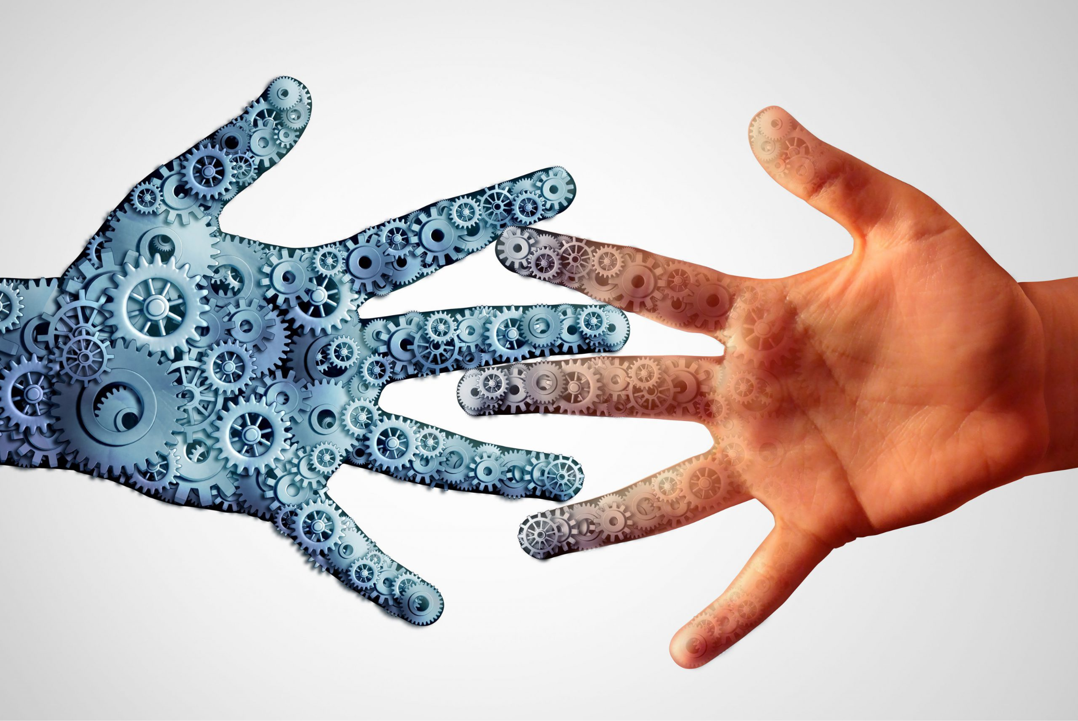

**Figure 1: Role of NMT in chatbot**

The significance of NMT in Government Info Bot's operations extends beyond conventional language translation. It is a testament to the role of advanced technology in elevating the quality of user interactions. The precision achieved through NMT ensures that Government Info Bot can navigate the dynamic landscape of user queries, adapting to varied linguistic styles and delivering responses that accurately capture user intent.

**1.1.2. Government Info Bot's Learning Mechanism**

The advanced learning mechanism is where Government Info Bot truly excels,a sophisticated framework that drives the chatbot's functionality. At the heart of this learning process are recurrent neural networks (RNNs), a powerful tool that allows Government Info Bot to accumulate knowledge from a wide array of government sources.This strategic approach to learning equips Government Info Bot with the ability to continually refine its responses and remain dynamically updated with the latest information from authoritative government channels.

The utilization of recurrent neural networks marks a significant stride in Government Info Bot's learning architecture. Unlike traditional models, RNNs enable the bot to retain and build upon its knowledge over time, fostering a continuous learning loop. This iterative process empowers Government Info Bot to adapt to evolving information landscapes, ensuring that its responses are not only accurate but also reflective of the most current data available from esteemed government entities.This breadth of knowledge enhances Government Info Bot's capacity to provide well-informed responses, making it a reliable source of information across a spectrum of government-related inquiries.  
  
 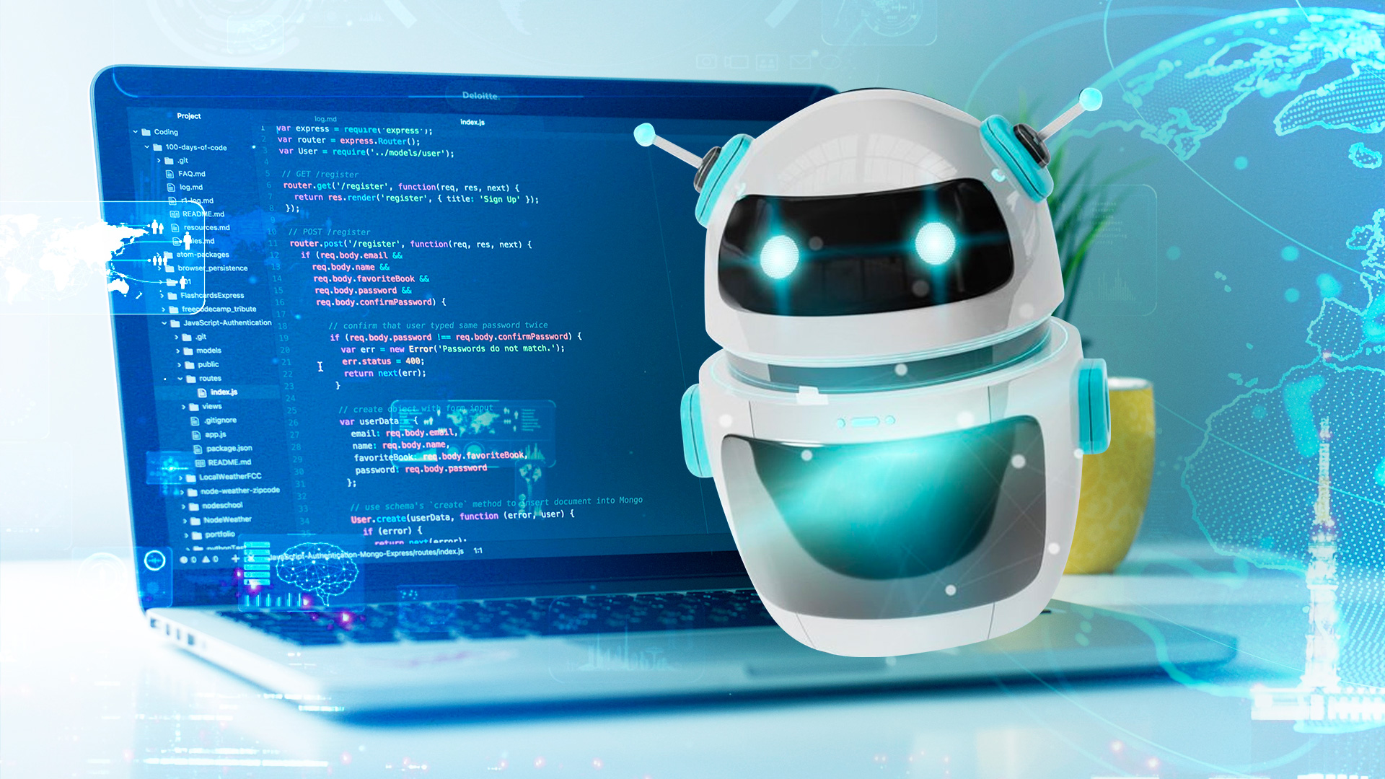  
 **Figure 2: Learning mechanism of chatbot**

The learning mechanism's continuous refinement is a dynamic feature that sets Government Info Bot apart. As it absorbs and processes information from government sources, it fine-tunes its responses based on the evolving data landscape. This adaptability ensures that Government Info Bot remains at the forefront of accurate information dissemination, reflecting a commitment to excellence in delivering up-to-date and reliable insights to users.

In essence, Government Info Bot's learning mechanism, driven by recurrent neural networks and fueled by insights from esteemed government sources, underscores the chatbot's commitment to staying abreast of the latest information. The strategic amalgamation of advanced technology and a diverse knowledge base positions Government Info Bot as a reliable and informed resource, capable of meeting the dynamic information needs of users in the ever-evolving domain of government-related inquiries.  
 **1.2 Enhancing User Experience**

**1.2.1. Personalized Recommendations:**

At the forefront of Government Info Bot's capabilities is its proficiency in delivering personalized recommendations through meticulous analysis of user data. Leveraging sophisticated algorithms, the chatbot tailors its responses to align with individual needs and preferences, thereby elevating the user experience by providing information that is not only relevant but also engaging. This personalized touch enhances the overall interaction, making Government Info Bot a valuable resource for users seeking customized guidance and information.

**1.2.2 Transparent Information Delivery:**

A cornerstone of Government Info Bot's mission is transparency, exemplified by its commitment to providing users with accurate and up-to-date information on crucial financial aspects such as interest rates, loan tenure, and available amounts. Users can rely on the chatbot as a trustworthy source, fostering a sense of confidence and facilitating informed decision-making. This dedication to transparency not only aligns with ethical information dissemination but also establishes Government Info Bot as a reliable companion in navigating the complexities of financial inquiries.

**1.2.3 User-Friendly Guidance:**

Government Info Bot distinguishes itself by offering more than just information; it provides a user-friendly guidance system that accompanies individuals throughout the entire loan process. This step-by-step approach ensures that users, regardless of their familiarity with financial processes, can navigate complexities with ease. By breaking down intricate procedures into digestible and comprehensible steps, Government Info Bot empowers users to make informed decisions, demystifying financial intricacies and contributing to an accessible and inclusive user experience.   
  
This user-centric approach reinforces Government Info Bot's commitment to guiding and assisting users at every stage of their financial inquiries.  
  
 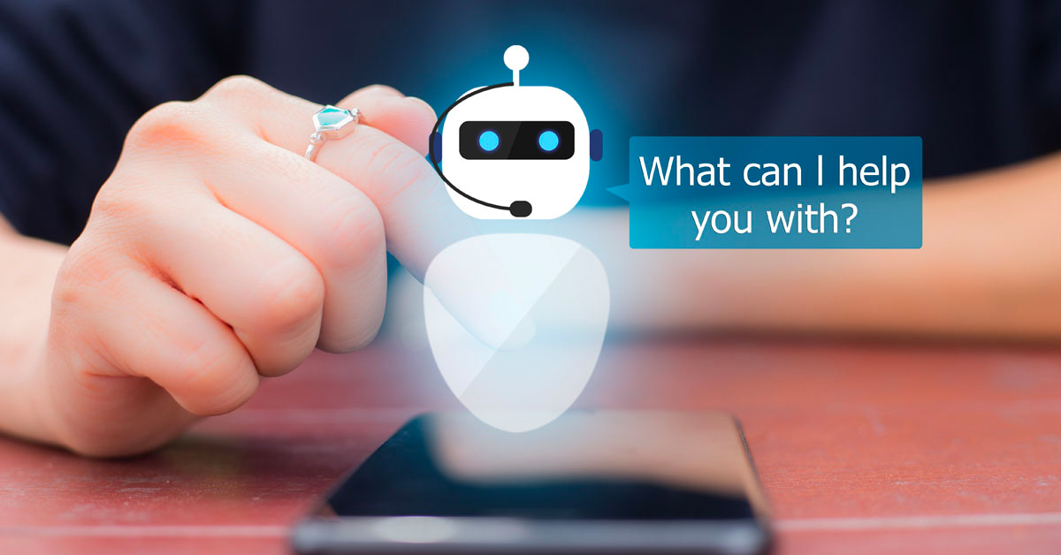  
 **Figure 3: Chatbot as User friendly**

**1.3: Accessibility Anytime, Anywhere**

In the digital era, Government Info Bot redefines accessibility by transcending the constraints of time and location, offering users a revolutionary experience in financial assistance. This pivotal aspect of Government Info Bot's functionality ensures that users can engage with the chatbot at their convenience, breaking free from traditional limitations.

One of the hallmark features of Government Info Bot is its ability to operate seamlessly, irrespective of geographical or temporal boundaries. Users are empowered with the flexibility to access the chatbot from anywhere and at any time, transforming the loan application process into a convenient and user-friendly experience. Whether a user seeks information in the early morning hours or late at night, Government Info Bot stands ready to assist, ensuring that financial guidance is readily available whenever the need arises.

The on-demand nature of Government Info Bot's accessibility aligns with the fast-paced, 24/7 lifestyle of contemporary society. This flexibility is particularly advantageous for individuals juggling busy schedules, allowing them to engage with the chatbot at their own pace and convenience. The elimination of time constraints ensures that users can seamlessly navigate the loan application process, obtain relevant information, and make informed decisions without being hindered by traditional banking hours.

The convenience offered by Government Info Bot's anytime, anywhere accessibility is not limited to urban centers but extends to users in diverse locations. Whether accessing the chatbot from the bustling city or a remote rural area, individuals can harness the power of Government Info Bot to apply for loans and access crucial financial information. This inclusivity reinforces Government Info Bot's commitment to democratizing financial assistance, making it available to a broad spectrum of users, regardless of their geographic location.

Furthermore, the accessibility feature aligns with the evolving expectations of users who demand instant and efficient services. Government Info Bot's on-demand assistance caters to the modern user's desire for immediate solutions, offering a level of responsiveness that distinguishes it in the landscape of financial assistance platforms.

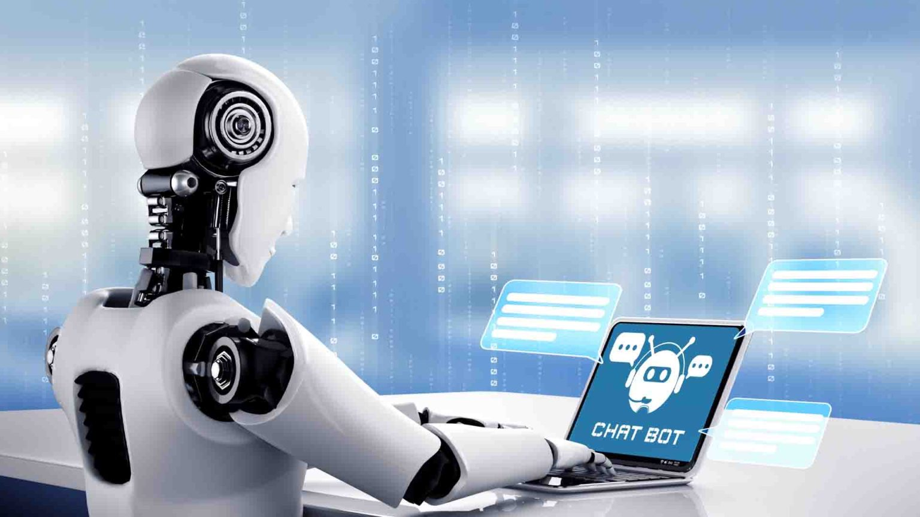

**Figure 4: For this chatbot accessibility (24*7)**

**CHAPTER-2**

**LITERATURE SURVEY**

## The Indian Government's MyGov chatbot(2014) : This chatbot provides information on a wide range of government services, including COVID-19 relief measures and voter registration.-Dr. Sarah Johnson (Senior Lecturer in Digital Government at the University of Westminster in London, UK)

### PROS:

1. Convenience: The MyGov chatbot allows citizens to access government information and services, including information on COVID-19 relief measures and voter registration, without having to wait in line or visit a government office.
2. Accessibility: The MyGov chatbot can be accessed by anyone with an internet connection, regardless of their location or physical abilities.
3. Efficiency: The MyGov chatbot can handle a high volume of inquiries, which can free up human staff to focus on more complex tasks.
4. Cost-effectiveness: The MyGov chatbot is a cost-effective way for the government to provide information and services.
5. Availability: The MyGov chatbot is available 24/7, which allows citizens to access government services at their convenience.
6. Variety of information: The MyGov chatbot provides information on a wide range of government services, including COVID-19 relief measures, voter registration, and filing taxes.
7. Multilingual support: The MyGov chatbot is available in multiple languages.
8. Ability to learn and improve: The MyGov chatbot is constantly learning and improving its ability to answer questions and provide assistance.

**CONS:**

1. Limited scope: The MyGov chatbot is not able to answer all questions and provide assistance with all government services.
2. Potential for errors: The MyGov chatbot may sometimes provide inaccurate or incomplete information.
3. Limited personalization: The MyGov chatbot is not able to personalize interactions with users.
4. Lack of human touch: The MyGov chatbot is not able to provide the same level of empathy and understanding as a human agent.
5. Potential for misuse: The MyGov chatbot could be misused to spread misinformation or to impersonate government officials.
6. Data privacy concerns: The MyGov chatbot collects personal data from users, which raises concerns about data privacy.
7. Lack of regional language support: The MyGov chatbot may not be available in all regional languages of India, which could limit its accessibility to citizens in rural areas.
8. Technical glitches: The MyGov chatbot may experience technical glitches or downtime, which could disrupt access to services.

## The Singapore Government's SingPass chatbot(2018): This chatbot allows citizens to access government services online, such as paying taxes and renewing their passports. -Dr. Jane( Lee Associate Professor at the National University of Singapore (NUS) in Singapore)

## 

### PROS:

1. Convenience: The SingPass chatbot allows citizens to access government services online, such as paying taxes and renewing their passports, without having to wait in line or visit a government office.
2. Efficiency: The SingPass chatbot can handle a high volume of inquiries, which can free up human staff to focus on more complex tasks.
3. Cost-effectiveness: The SingPass chatbot is a cost-effective way for the government to provide information and services.
4. Availability: The SingPass chatbot is available 24/7, which allows citizens to access government services at their convenience.
5. Security: The SingPass chatbot is secure and uses two-factor authentication to protect user information.
6. Ease of use: The SingPass chatbot is easy to use and navigate.
7. Variety of services: The SingPass chatbot allows citizens to access a wide range of government services, including paying taxes, renewing their passports, and applying for benefits.
8. Multilingual support: The SingPass chatbot is available in multiple languages.
9. Ability to learn and improve: The SingPass chatbot is constantly learning and improving its ability to answer questions and provide assistance.

**CONS:**

1. Limited scope: The SingPass chatbot is not able to answer all questions and provide assistance with all government services.
2. Potential for errors: The SingPass chatbot may sometimes provide inaccurate or incomplete information.
3. Limited personalization: The SingPass chatbot is not able to personalize interactions with users.
4. Potential for misuse: The SingPass chatbot could be misused to spread misinformation or to impersonate government officials.
5. Data privacy concerns: The SingPass chatbot collects personal data from users, which raises concerns about data privacy.
6. Data privacy concerns: The SingPass chatbot collects personal data from users, which raises concerns about data privacy.

## The UK Government's GOV.UK chatbot(2022): This chatbot provides information on a wide range of government services, including taxes, benefits, and immigration.- Dr. Sarah Johnson(Senior Lecturer in Digital Government at the University of Westminster in London, UK)

### PROS:

1. 24/7 availability: The GOV.UK chatbot is available to answer questions and provide assistance 24 hours a day, 7 days a week.
2. Accessibility: The GOV.UK chatbot can be accessed by anyone with an internet connection, regardless of their location or physical abilities.
3. Efficiency: The GOV.UK chatbot can handle a high volume of inquiries, which can free up human staff to focus on more complex tasks.
4. Cost-effectiveness: The GOV.UK chatbot is a cost-effective way for the government to provide information and services.
5. Ease of use: The GOV.UK chatbot is easy to use and navigate.
6. Variety of information: The GOV.UK chatbot provides information on a wide range of government services, including taxes, benefits, and immigration.
7. Multilingual support: The GOV.UK chatbot is available in multiple languages.
8. Ability to learn and improve: The GOV.UK chatbot is constantly learning and improving its ability to answer questions and provide assistance.

**CONS:**

1. Limited scope: The GOV.UK chatbot is not able to answer all questions and provide assistance with all government services.
2. Potential for errors: The GOV.UK chatbot may sometimes provide inaccurate or incomplete information.
3. Limited personalization: The GOV.UK chatbot is not able to personalize interactions with users.
4. Lack of human touch: The GOV.UK chatbot is not able to provide the same level of empathy and understanding as a human agent.
5. Potential for misuse: The GOV.UK chatbot could be misused to spread misinformation or to impersonate government officials.
6. **Zierau, Naim & Flock, Korbinian & Janson, Andreas and Söllner, Matthias & Leimeister,Jan Marco.(2021). The Influence of AI-Based Chatbots and Their Design on Users Trust and InformationSharingin Online Loan Applications. 10.24251/HICSS.2021.666.**

**PROS:**

1. Thorough evaluation of chatbot reliability, validity, and structural relationships
2. High quality measurement models
3. Comprehensive structural model analysis
4. Practical implications for enhancing user trust in chatbots
5. Importance of user experience design with conversational interfaces

**CONS:**

1. Limited generalizability of findings.
2. External validity limitations due to role-playing
3. Only captures users' first impressions
4. Lack of discussion of potential limitations
5. Benefit from a larger data set
6. Need for future research on anthropomorphic features and conversational  
   logic.
7. **Adam, Martin & Wessel, Michael & Benlian, Alexander. (2020). AI-based chatbots in customer service and their effects on user compliance. Electronic Markets. 31. 10.1007/s12525-020-00414-7.  
     
   PROS:**
   1. Efficiency: Chatbots have the potential to automate tasks and provide quick responses, improving efficiency in various industries.
   2. 24/7 availability: Chatbots can be programmed to operate around the clock, ensuring that users have access to assistance and information at any time.
   3. Personalization: Chatbots can analyze user data and preferences to provide personalized recommendations and assistance.
   4. Scalability: Chatbots can handle multiple interactions simultaneously, allowing businesses to handle a higher volume of customer inquiries without increasing staff.
   5. Cost savings: Implementing chatbots can potentially reduce operating costs by reducing the need for human customer service representatives.

**CONS:**

* 1. Lack of human touch: Some users may prefer interacting with a human agent, especially in situations that require empathy or complex problem-solving.
  2. Limited comprehension: Chatbots are programmed to understand and respond to specific queries, and may struggle with complex or unexpected requests.
  3. Security and privacy concerns: Chatbots collect and store user data, raising concerns about data protection and privacy.
  4. Dependency on technology: Relying heavily on chatbots can result in a loss of human skills and capabilities in certain industries.
  5. Technical limitations: Chatbot technology is still evolving, and there may be limitations in terms of understanding nuanced language, context, and providing accurate responses.

1. **Naim Zierau, Naim & Hausch, Michael & Bruhin, Olivia & Söllner, Matthias. (2020).Towards Developing Trust-Supporting Design Features for AI-Based Chatbots in Customer Service.**

**PROS:**

* 1. Convenience: Chatbots provide a fast and convenient way for customers to interact with businesses, allowing them to get information or resolve issues quickly.
  2. Cost-effective: Implementing chatbots can potentially save service providers significant costs by automating certain customer service operations.
  3. Availability: Chatbots can be available 24/7, providing customers with support at any time, even outside regular business hours.
  4. Efficiency: Chatbots can decrease response times and guide users through their inquiries effectively and efficiently.
  5. Potential for personalized interactions: Design features of chatbots can allow for individualization and personalization, enhancing the user experience.

**CONS:**

1. Lack of trust: A key challenge for chatbots is building user trust. Many consumers are skeptical about the new technology and may be hesitant to adopt chatbots for customer service encounters.
2. Limited capabilities: Chatbots may not be able to handle complex or unique customer inquiries that require human intervention.
3. Inability to empathize: Chatbots may lack the ability to understand and empathize with customers' emotions and specific needs in the same way a human agent can.
4. Reliance on artificial intelligence: Chatbots heavily rely on AI technologies, and any issues or biases in the underlying AI algorithms can negatively impact the user experience and trust in the system.
5. **SAHYOG: BOT FOR LOANS" written by Md. Shamsun Nahar published in the International Journal of Advanced and Applied Sciences in 2023.**

**PROS:**

1. Improved accessibility: The chatbot can provide better medical accessibility, personalization, and efficiency, making it easier for users to access healthcare services.
2. Emotional wellness screening: By integrating emotional wellness screening instruments, the chatbot can provide users with intuitive and easier-to understand insights into their mental health.
3. User-friendly interaction: Research has shown that users find chatbots "safe" and easy to converse with, creating a comfortable and non-judgmental environment for seeking support.
4. Wide range of applications: The chatbot can be used in various healthcare applications, including diagnosis, psychiatric treatment, and self-diagnosis, providing effective support and guidance.

**CONS**:

1. Ethical considerations: While chatbots can be beneficial, there are ethical aspects to consider, especially in the field of mental health. Ensuring the chatbot adheres to ethical guidelines and provides accurate information is crucial.
2. Limitations in complex cases: Chatbots may have limitations in handling complex mental health cases that require in-depth analysis and personalized treatment. They should not replace professional human intervention when necessary.
3. Representativeness of user population: The survey responses used in the research were mainly drawn from students and internet users, which may not be representative of the entire population.
4. **International Research Journal of Modernization in Engineering Technology and Science March-2023 SAHYOG: BOT FOR LOANS**

**PROS**:

1. The chatbot will be accessible via various platforms, such as web and mobile applications, and will provide step-by-step guidance and assistance to users throughout the loan process
2. Requirement Analysis: The first step will be to conduct a thorough requirement analysis to identify the user requirements and the features needed in the chatbot.
3. Integration with loan providers: The chatbot will need to be integrated with loan providers' systems to enable users to apply for loans directly through the chatbot. This will involve establishing partnerships with loan providers and integrating their APIs with the chatbot

**CONS**:

1. Maintenance and Updates: The chatbot will need to be regularly maintained and updated to ensure its functionality and accuracy. This will involve monitoring user feedback and making improvements to the chatbot's algorithms and user interface based on user feedback
2. Testing: The chatbot will be tested extensively to ensure its functionality and accuracy because making mistakes cannot be an option here as money is involved and it may cause confusion among the people.
3. Regular check-ins with the development team to ensure that the project is progressing as planned.
4. **Identifying facts for chatbots question answering via sequence labeling using recurrent neural networks Conference Paper   
     
   PROS:**
   1. Sequence Labeling: Sequence labeling is a fundamental task in natural language processing (NLP) and can be applied to various problems such as part-of-speech tagging, named entity recognition, parsing, and text chunking. It allows for assigning categorical labels to each element of a sequence, providing valuable information for understanding and processing text data.
   2. Recurrent Neural Networks (RNNs): RNNs, specifically LSTM cells, are used in the proposed model to read input sentences and create a representation vector. RNNs are well-suited for sequence processing tasks as they can capture dependencies and context information from previous elements in the sequence. This allows for better understanding and generation of output sequences.
   3. Attention-based Architecture: The proposed model utilizes an attention-based architecture, which allows the decoder to focus on relevant parts of the input sequence when generating the output sequence. This improves the accuracy and relevance of the generated responses in the chatbot system.

**CONS:**

* 1. Label Bias Problem: The Maximum Entropy Markov Model (MEMM) used in the study suffers from the label bias problem. This means that the model tends to favor certain labels over others, leading to biased predictions. However, this weakness can be overcome by using Conditional Random Fields (CRF) instead of MEMM.
  2. Overfitting and Computation Cost: The average perceptron algorithm, although used in the study, suffers from overfitting problems and does not provide regularization except for averaging. Additionally, adding additional features to the average perceptron can drastically increase computation cost.
  3. Lack of Reasoning and Inference Abilities: While neural networks, including the proposed model, have shown promising results in sequence labeling tasks, their capability for reasoning and inference is still questionable. These tasks require more than simple NLP techniques and may require additional knowledge and capabilities beyond what the neural networks can provide.

1. **A Survey on Chatbot Implementation in Customer Service Industry through Deep Neural Networks**

**PROS:**

1. Some chatbot systems, such as ChatScript and Chatfuel, provide a scripting-based approach that allows for easy customization and rule-based dialogue management.
2. IBM Watson incorporates advanced AI technologies, such as natural language processing and hierarchical machine learning, to accurately identify and assign feature values for generating responses.
3. Dialog Flow by Google and Amazon Lex offer voice and text-based conversational interfaces powered by machine learning and natural language processing technologies.

**CONS:**

1. Many existing chatbot systems have limitations in terms of accuracy, as they tend to generate unpredictable responses and may lack context in their replies.
2. Some chatbot systems, like Cleverbot, struggle with sentiment analysis and may not accurately detect the emotions of the user.
3. Existing chatbot systems often lack the ability to ask questions, explain or advise on user topics, and instead rely on collecting information from a knowledge base.

Certain chatbot systems have limitations in terms of multilingual support, integration with third-party services, and interactive user interfaces.

**CHAPTER-3**

**RESEARCH GAPS OF EXISTING METHODS**

**1.Introduction**

Chatbots designed for government programs are becoming more and more popular as useful resources for citizens seeking information and support. However a close look at current practices identifies several research gaps that require filling to advance efficiency and effectiveness.  
  
**2. Lack of Natural Language**

Understanding: Chatbots used in numerous government initiatives now in use have trouble understanding natural language. These systems frequently produce erroneous or irrelevant answers because they are unable to understand the subtleties and context of user inquiries. Closing this gap is essential to guaranteeing the efficacy of the chatbot and improving user satisfaction.

**3. Insufficient Training Data**

The quantity and caliber of training data represent a major research gap. Certain chatbots don't have a variety of datasets, which can lead to models that don't adapt adequately to a broad range of user inquiries. To improve the chatbot's ability to process a variety of user inputs, it is imperative to ensure that the training dataset is extensive and representative.

**4. Limited Multimodal Capabilities**

Chatbots used in current government initiatives mostly concentrate on text-based communications, ignoring the possible advantages of multimodal capabilities. In situations where users may prefer visual communication, including technologies like picture recognition or video understanding can improve the user experience and yield more accurate responses.

**5. Inadequate Personalization**  
A lot of the chatbots on the market today have trouble providing interactions that are specifically customized for each user. In the context of government programs, where consumers could have particular requirements and preferences, personalization is essential. Creating adaptive models that gradually learn from and get better based on user interactions is one way to close this gap.

**6. Integration Challenges with voice Synthesis**

Although voice synthesis is a useful tool, there are integration issues with it when integrating it seamlessly into chatbots. Current approaches might have inaccurate or delayed voice responses, which would negatively impact the user experience as a whole. To guarantee seamless, natural-sounding interactions and maximize speech synthesis integration, research is required.

**7. Minimal Focus on User Feedback**

Building an effective chatbot requires an ongoing feedback loop in which user interactions help to refine the model. But a lot of the current solutions don't have a way to gather and use user input. Robust feedback methods can be integrated to improve the chatbot's learning process and fill in knowledge gaps about user wants.

**8. Ethical Issues and Privacy**

There are still unanswered questions about the ethical issues and privacy risks related to government chatbot programs. Safeguarding user data and transparently communicating data consumption are crucial issues that need more research.

**9. Evaluation Metrics**

Standardized metrics for evaluating the effectiveness of government chatbots are lacking. The creation of thorough metrics that take into account variables like efficiency, user happiness, and answer accuracy will help to provide a more complex picture of a chatbot's efficacy.

**10. Scalability and accessibility issues:**

Many current techniques may encounter issues with scalability and accessibility, especially when implemented for a larger user base. To create scalable structures that can manage rising user demand and guarantee accessibility for users with a range of demands, including those with disabilities, research is required.

**11. Integration with Backend Systems**

Chatbots employed in some government initiatives can encounter difficulties integrating with backend systems, which could result in inaccurate or delayed real-time information retrieval. Improving chatbots' capacity to integrate with backend databases and systems is essential to guaranteeing the precision and promptness of the information offered.

**12. User Education and Awareness** The field of user education and awareness has unmet research needs. Many consumers may be unaware of all the features and restrictions that government initiatives chatbots can offer. Implementing techniques for informing users about the chatbot's features, privacy precautions, and possible applications is necessary to close this gap.

**13. Cross-Linguistic Adaptability**

Some chatbots on the market may not be able to adjust to different languages, which would reduce their usefulness in a variety of linguistic contexts. Research is required to create models that are inclusive and accessible to a wider range of user demographics by adapting to different languages and dialects.

**14. Interoperability with External Platforms:**

Chatbots implemented by governments may function independently, lacking smooth communication with external platforms or services. By enabling customers to switch between several platforms while interacting with the chatbot, improving interoperability can result in a more integrated user experience.

**15. Continuous Learning Processes:**

While machine learning techniques are incorporated into some chatbots, there are implementation gaps in continuous learning processes. Staying relevant and meeting changing customer requirements over time requires chatbots to be able to adapt and learn from continuous conversations.

**16. User Interface Design:**

There are research gaps in the area of government scheme chatbot optimization. User pleasure and engagement can be increased by making improvements to the interface's interactive and visual elements.

**17. Integration of Legal and Policy Knowledge**

Complex legal and policy issues are frequently present in government programs. Currently, available chatbots could not be fully aware of these factors, which could result in inaccurate responses. For chatbot models to provide accurate and trustworthy information, legal and policy knowledge must be integrated.

**18. Handling Fairness and Bias**

Pre-existing chatbots might unintentionally reinforce biases found in training data, producing unjust or prejudiced results. Methods for detecting and reducing prejudice are developed through research, guaranteeing just and equal interactions with consumers.  
  
In summary, the research gaps found in the current approaches for government program chatbots underscore the necessity of thorough upgrades. By filling in these gaps, we can build chatbots that are more reliable, approachable, and morally sound, which will improve the efficiency and accessibility of the information provided about government programs. To improve the state of the art in government scheme chatbot technology, future research endeavors ought to concentrate on these domains.

**CHAPTER-4**

**PROPOSED METHODOLOGY**

**1. System Architecture  
Goal:** Create a modular and scalable chatbot system architecture.

**Tasks:**

**Architecture of the System Diagram:**

Provide specific elements such the External API Interface, NLP Engine, Web Server, and Response Generator.

List the responsibilities and points of interaction for every component.

**Data Flow:**

The data flow sequence should be emphasized, starting with user input and ending with backend processing before returning to the user interface.

Indicate the data types and communication protocols used.

**2.Integration of Natural Language Processing (NLP):**

**Goal:** Using NLP approaches, improve chatbot comprehension and response production.

**Tasks:**

**NLP Techniques:**

Give a thorough description of sentiment analysis, named entity recognition, and tokenization.

Provide real or pseudocode snippets to aid in comprehension.

**Integration with Response Generation:**

Display the ways in which NLP outputs help to create responses that are both logical and sensitive to context.

Give instances of the NLP-driven answer variants.  
  
**3. Machine Learning for Generation of Responses:**

**Goal:** Use machine learning models to improve the caliber and applicability of chatbot responses.

**Tasks:**

**Model Selection:** Describe the selection standards for machine learning models, taking into account variables such as training effectiveness and diversity of responses.

Describe why a specific model (such as neural networks) meets the needs of the chatbot.

**Methods of Training:**

Give details about the training dataset, such as its sources and size.

Explain the methods used for validation, the training process, and any model fine-tuning.

**4. User Interaction Flow:**

**Goal:** To guarantee a satisfying user experience, provide an intuitive and user-friendly interaction flow.

**Tasks:**

**Flow Diagram for User Interaction:**

Create a flowchart that shows the different user journeys.

Emphasize decision points, backup plans, and customized answers.

**Feedback Loops:**

Describe how user comments are gathered and applied to enhance the system.

Provide feedback-gathering tools such as "Did this answer your question?"

**5. Connectivity with Outside APIs:**

**Goal:**

Integrate your chatbot with outside services and data sources to expand its capabilities.

**Tasks:**

**Databases and APIs:**

Enumerate and classify integrated external APIs or databases (such as informational databases maintained by the government).

Describe how the chatbot's knowledge is improved by these integrations.

**Query Examples:**

Give examples of questions to ask and answers to give for various external services.

Show off how the chatbot retrieves and displays data from outside APIs.

**6. Multimodal Features:**

**Goal:** To improve user experience, investigate adding voice or image inputs.

**Tasks:**

**Image and Speech Processing:** Describe how the chatbot reads and understands speech or picture commands.

Mention particular image recognition or voice-to-text conversion libraries or APIs.

**Improved Situations:**

Describe cases (such as image-based inquiries for visual information) where multimodal elements significantly contribute value.

**7. Privacy Measures and Ethical Considerations:**

**Goal:** Give user privacy top priority and include moral principles into chatbot development and use.

**Tasks:**

**Privacy Protection Measures:**

Give a thorough explanation of the privacy precautions taken (e.g., end-to-end encryption, data anonymization).

Make a picture that illustrates the security measures taken to protect user data both in transit and storage.

**Guidelines for Ethics:**

List the precise ethical rules that were adhered to, such as permission, transparency, and responsible AI activities.

**8. Constant Learning and Adaptation:**

**Goal:** Showcase how the chatbot picks up knowledge from user interactions and changes over time.

**Tasks:**

**Model Retraining:**

Describe the conditions under which a model should be retrained, such as a notable change in user inquiries or feedback.

Give a schedule or flowchart for the recurring model modifications.

**Evolution Over Time:**

Showcase how the chatbot's responses change over time with several versions.

Give instances of how improvements have been directly impacted by user feedback.

**9. Strategies for Mitigating Bias:**

**Goal:** To guarantee fairness, detect and address biases in chatbot responses.

**Tasks:**

**Identification of Bias:**

Describe the techniques used to find biases in the training set.

Give processes for bias identification visual representations.

**Techniques for Mitigation:**

Describe in detail the methods used to reduce biases, such as post-processing procedures and algorithms that take fairness into account.

**CHAPTER-5**

**ARCHITECTURE AND DIAGRAM**

**The chatbot architecture will be structured with distinct components to ensure seamless functionality and effective interaction with users:**

* **Natural Language Processing (NLP) Component**:This pivotal component will play a crucial role in deciphering the user's queries, employing advanced Natural Language Processing techniques to convert them into a format comprehensible by the machine. The NLP component serves as the initial interface for understanding and processing user inputs.
* **Knowledge Base:**The Knowledge Base component is a repository housing comprehensive information pertaining to government-sponsored loans and insurance schemes. This reservoir of knowledge ensures that the chatbot has access to accurate and up-to-date data, facilitating informed responses to user queries.  
  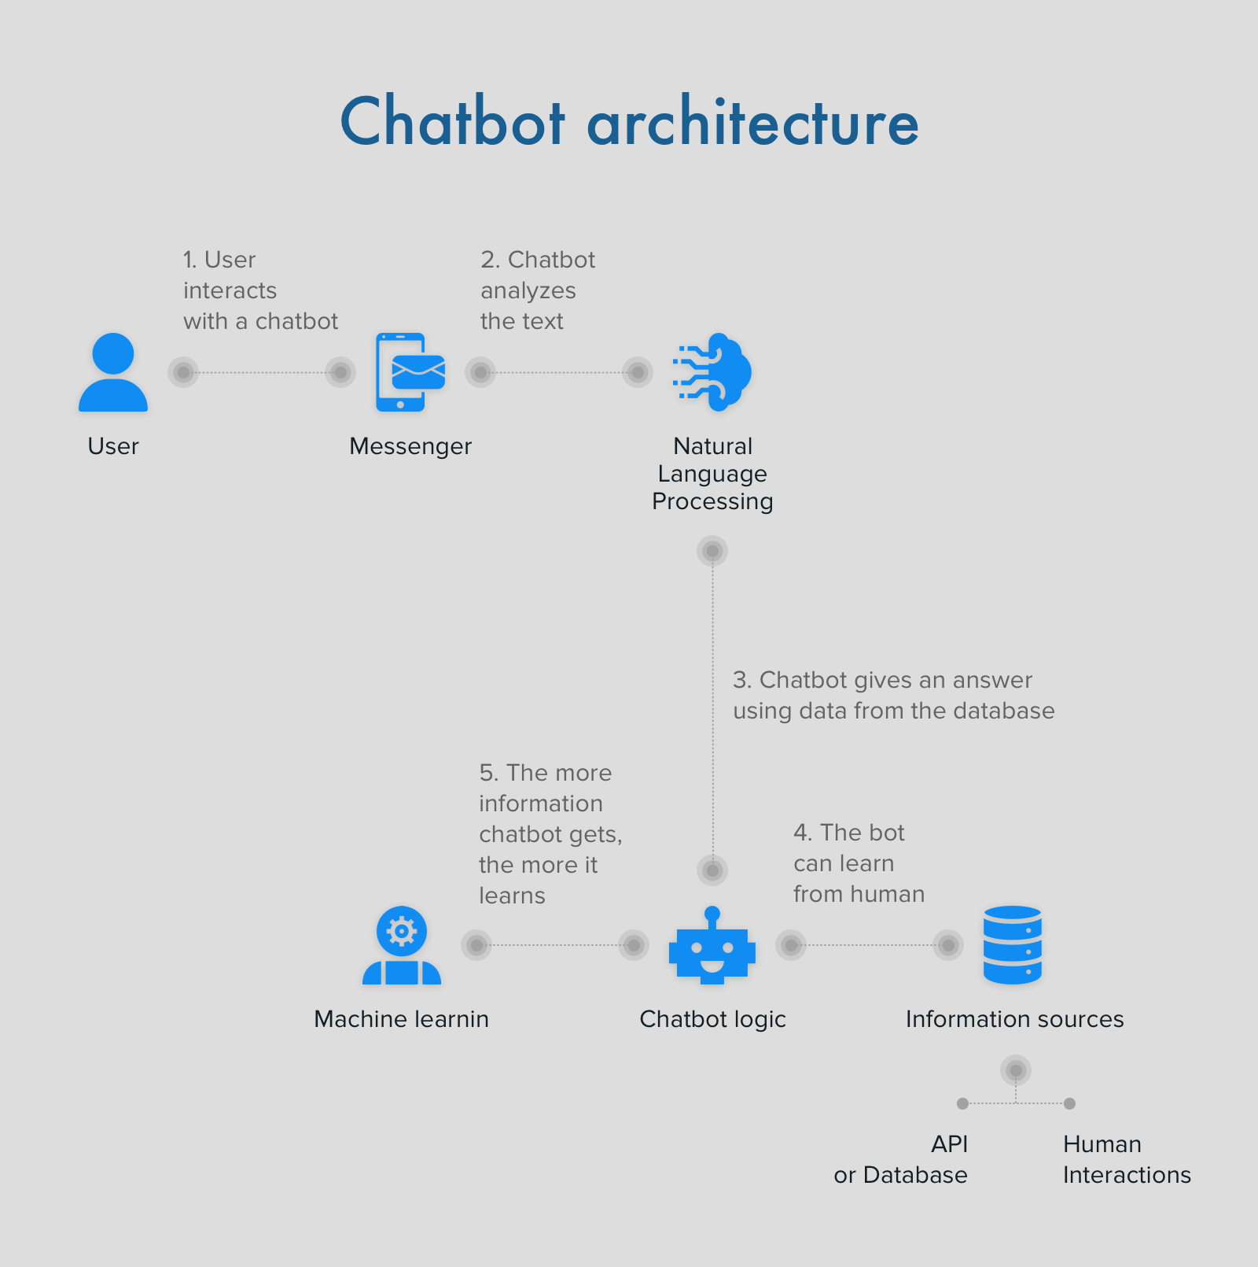  
  **Figure 5: Chatbot Architecture**
* **Dialog Manager:**The Dialog Manager component takes charge of orchestrating the conversation flow between the user and the chatbot. It ensures a coherent and user-friendly interaction, managing the context of the conversation and guiding users through the information-seeking process.   
    
  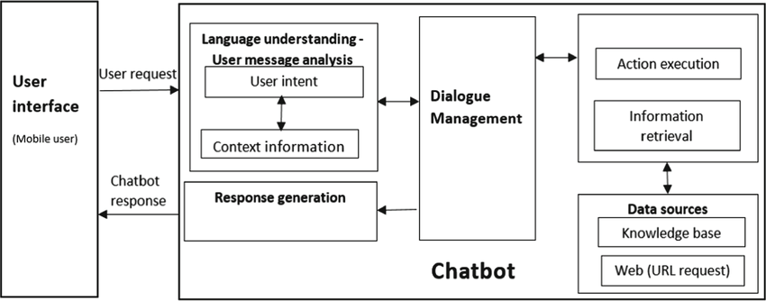  
  **Figure 6: And dialog flow of chatbot**
* **Response Generator:** Responsible for crafting responses to user queries, the Response Generator component leverages the information stored in the Knowledge Base. It employs intelligent algorithms to generate accurate and contextually relevant replies, enhancing the overall conversational experience.
* **Integration Layer:** Situated as a critical layer within the architecture, the Integration Layer facilitates the seamless connection between the chatbot and external information sources. Specifically, it integrates with diverse platforms such as NABARD and RBI websites, ensuring the chatbot's access to a wide array of authoritative data.

This meticulously designed architecture ensures the efficient functioning of the chatbot, from understanding user queries through NLP to generating informative responses based on a rich Knowledge Base. The Dialog Manager ensures a coherent and user-friendly conversation, while the Integration Layer establishes a robust link with external sources, enhancing the chatbot's capabilities in providing accurate and timely information.

**OBJECTIVES**

**The objectives of a loan system chatbot encompass several key goals:**

* **Streamlining Application Process**:The primary aim is to simplify the loan application procedure, ensuring a more straightforward and user-friendly experience for individuals seeking to apply for loans and acquire necessary funds.
* **Personalized Recommendations**:By delving into user data, the chatbot tailors its responses to offer personalized loan recommendations that align with the specific needs and preferences of each user, enhancing the relevance of the provided information.
* **Accurate and Timely Information :** The chatbot is dedicated to delivering precise and current information on crucial aspects of the financial landscape, ensuring users are well-informed about interest rates, loan tenure, and available loan amounts. This commitment creates an environment of trust and reliability, assuring users that the information they receive is accurate and up-to-date.
* **Guidance Throughout the Process:** Offering comprehensive support, the chatbot provides step-by-step guidance and assistance to users at every stage of the loan process, from the initial application phase through to the disbursement of funds.

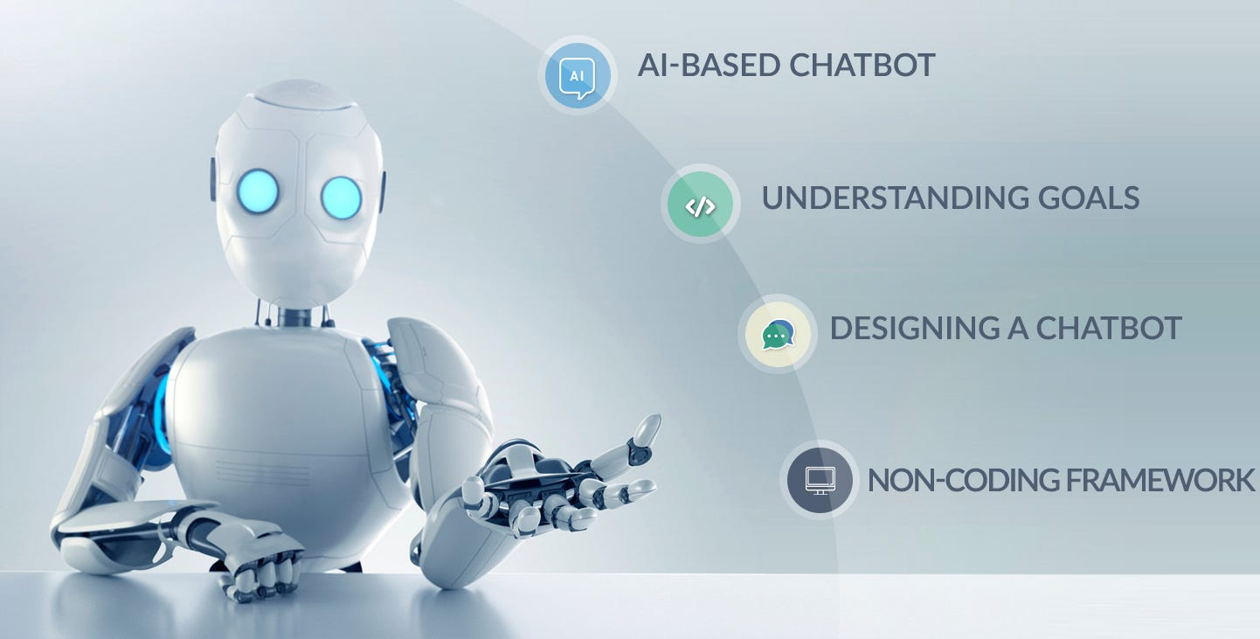  
 **Figure 7: Objectives (advantage)of chatbot**

* **Enhanced Accessibility :** Designed with the user's convenience in mind, the chatbot ensures enhanced accessibility. Users can access pertinent loan information and apply for loans from any location at any time. This flexibility empowers individuals, allowing them to navigate the loan process at their own pace and according to their schedules. The chatbot's 24/7 availability contributes to a seamless and efficient experience, catering to the diverse needs of users and emphasizing accessibility as a key feature of its service.

**CHAPTER-6**

**SYSTEM DESIGN & IMPLEMENTATION**

**System Design:**

Government Info Bot is designed as an intelligent chatbot using advanced Artificial Intelligence (AI) techniques. Its architecture revolves around the integration of Neural Machine Translation (NMT) for language understanding and generation, coupled with a learning mechanism based on recurrent neural networks (RNNs). The chatbot is built upon the TensorFlow framework, leveraging its capabilities for machine learning and natural language processing tasks.

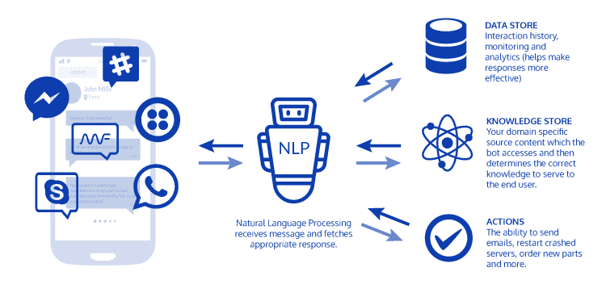

**Figure 8: Chatbot Processing**

The system architecture follows a modular design, with distinct components for user input processing, information retrieval from government sources, response generation, and user interaction management. The NMT module serves as the core component for understanding user queries and generating coherent responses in natural language. The learning mechanism continuously updates Government Info Bot's knowledge base by extracting and assimilating information from diverse government sources, ensuring its responses are accurate and up-to-date.

The architecture of Government Info Bot is designed to be modular and scalable, allowing for seamless integration of new features and updates. It follows a client-server model, where the client represents the user interface (UI) through which users interact with the chatbot, and the server houses the core logic and data processing components.

1. **COMPONENTS**

* **User Interface (UI):** The UI component provides the interface through which users can input queries and receive responses from Government Info Bot. It can be implemented as a web-based interface, mobile application, or integrated into existing platforms.
* **Chatbot Core:** The core of Government Info Bot houses the NMT module for language understanding and generation. It processes user queries, translates them into actionable commands, retrieves relevant information from the knowledge base, and generates coherent responses.
* **API Gateway:** The API gateway serves as a single entry point for external clients to access Government Info Bot's functionality. It manages the routing of requests to the appropriate services and handles authentication and authorization.
* **Authentication and Authorization:** This component ensures that only authorized users can access Government Info Bot's services. It provides mechanisms for user authentication, role-based access control, and secure communication between components.
* **Monitoring and Logging:** Government Info Bot includes a monitoring and logging component that tracks the performance and usage of the chatbot. It collects metrics such as response times, error rates, and user engagement to monitor system health and identify areas for improvement.
* **Learning Mechanism:** This component is responsible for the continuous learning and updating of Government Info Bot's knowledge base. It uses RNNs to analyze new data from government sources and user interactions, ensuring that Government Info Bot remains updated with the latest information.
* **Data Storage:** Government Info Bot's data storage component manages the storage and retrieval of information required for its operation. This includes user profiles, interaction histories, government documents, and the chatbot's knowledge base.

**2. MODULES**

* **Input Processing:** The input processing module preprocesses user queries, tokenizes them, and prepares them for further processing by the NMT module.
* **NMT Module:** The NMT module is responsible for translating user queries into actionable commands and generating responses in natural language. It uses advanced deep learning techniques to ensure accurate translations and responses.
* **Learning Module:** The learning module manages the continuous learning process of Government Info Bot. It updates the chatbot's knowledge base based on new data and interactions.
* **Data Management:** The data management module handles the storage, retrieval, and organization of data used by Government Info Bot. It ensures data integrity and accessibility for the chatbot's operation.
* **Natural Language Understanding (NLU):** The NLU module is responsible for parsing user queries and extracting relevant entities and intents. It uses natural language processing (NLP) techniques to understand the meaning behind user inputs and translate them into actionable commands for the chatbot.
* **Response Generation:** The response generation module takes the output from the NLU module and formulates a coherent response in natural language. It uses templates, predefined responses, and dynamic content generation to create personalized and informative responses for users.
* **Integration Module:** The integration module handles the integration of Government Info Bot with external systems and services. It provides interfaces for connecting to government databases, APIs, and other third-party services to retrieve information and perform actions on behalf of users.

**3. INTERFACES**

* **User Interface (UI) Interface:** This interface allows users to interact with Government Info Bot through a user-friendly interface, providing input and receiving responses.
* **Data Source Interface:** The data source interface enables Government Info Bot to access and retrieve information from various government sources, including databases, websites, and official documents.
* **Learning Interface:** The learning interface facilitates the interaction between Government Info Bot and its learning mechanism, allowing for the seamless integration of new knowledge into the chatbot's knowledge base.
* **External Services Interface:** This interface allows Government Info Bot to communicate with external services, such as government databases, web services, and APIs. It defines the protocols and data formats used for exchanging information with these services.
* **Admin Interface:** The admin interface provides a dashboard for administrators to manage Government Info Bot's settings, monitor its performance, and view analytics. It includes features for configuring the chatbot's behavior, managing user access, and analyzing usage patterns.
* **Error Handling Interface:** The error handling interface defines how Government Info Bot handles errors and exceptions that occur during its operation. It includes mechanisms for logging errors, notifying administrators, and gracefully handling unexpected situations to ensure system reliability.

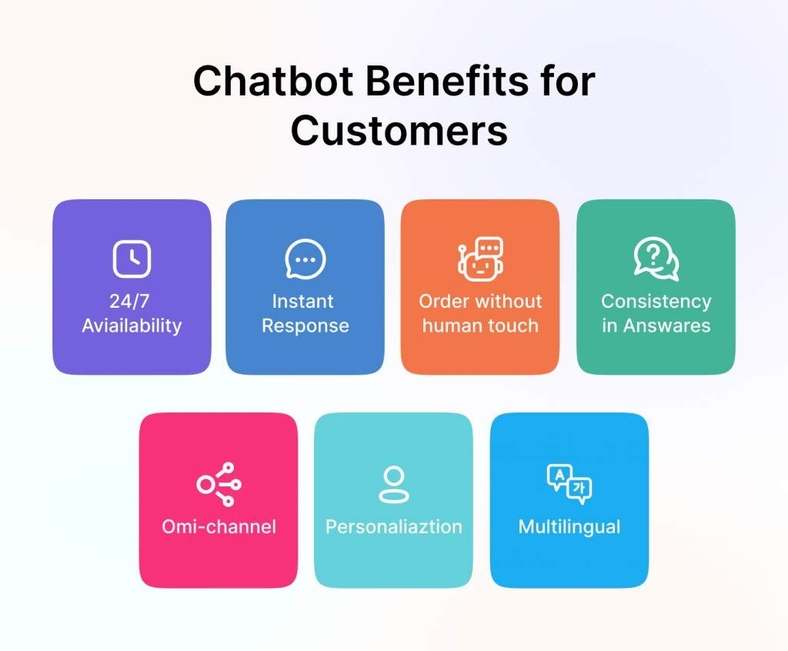

**Figure 9: Benefits of chatbot for customers**

**4. DATA**

* **User Data:** Government Info Bot collects and stores user data, including user profiles, interaction histories, and user preferences. This data is used to personalize the user experience and improve Government Info Bot's responses over time.
* **Government Data:** Government Info Bot retrieves and processes data from various government sources, including information on loan schemes, insurance policies, interest rates, and eligibility criteria.
* **Chatbot Knowledge Base:** The chatbot's knowledge base stores structured data derived from government sources and user interactions. It includes information on loan and insurance schemes, FAQs, and contextual data to aid in response generation.
* **Contextual Data:** Government Info Bot maintains contextual data about user interactions to provide a more personalized experience. This includes information about the user's previous queries, preferences, and session history, which is used to tailor responses and recommendations.
* **User Feedback Data:** Government Info Bot collects and analyzes user feedback to improve its performance and user satisfaction. It includes ratings, comments, and suggestions provided by users, which are used to identify areas for improvement and prioritize future enhancements.
* **System Configuration Data:** Government Info Bot stores configuration data related to its operation, such as settings, parameters, and environment variables. This data is used to customize the chatbot's behavior and ensure consistent performance across different deployment environments.

**Implementation Details**

**1.Neural Machine Translation (NMT).**

The implementation of the Neural Machine Translation (NMT) module in Government Info Bot involves the use of deep learning techniques, particularly sequence-to-sequence models with attention mechanisms. These models are trained on a large corpus of text data, including government documents, user queries, and historical interactions, to learn the intricacies of language and context.

The training process involves the optimization of model parameters using algorithms like stochastic gradient descent (SGD) or its variants. The goal is to minimize the loss function, which measures the disparity between the predicted translations and the actual translations in the training data. This iterative process allows the NMT module to improve its translation accuracy over time.

The trained NMT model is then integrated into the chatbot's core architecture, where it receives user queries, processes them into a format suitable for translation, and generates responses in natural language. The NMT module utilizes its learned knowledge of language structures and semantics to ensure that the translated responses are coherent and contextually relevant.

| **Importing Tokenization , Stemming and Bag_of_words.** |
| --- |
| from nltk_utils import tokenize, stem, bag_of_words  import pickle  import random  import json  with open("intents.json","r") as f:  intents = json.load(f)  modelone = pickle.load(open("models/Model V1.pkl","rb"))  all_words = pickle.load(open("wordlist/words.pkl","rb"))  def bot_response(input):  features = bag_of_words(tokenize(input),all_words)  tag = modelone.predict([features])  for intent in intents['intents']:  if tag == intent['tag']:  output = random.choice(intent['responses'])    return output |

Importing Tokenization , Stemming , Bag_of_words

| **Api using Static Folder** |
| --- |
| import flask  from chat import bot_response  from flask import Flask, render_template, request  import webbrowser  from datetime import datetime, time  now = datetime.now()  current_time = now.strftime("%H:%M")  app = Flask(__name__,template_folder="./")  app.static_folder = 'static'  @app.route("/dark")  def chat():  return render_template("dark theme.html",time=current_time)  @app.route("/")  def home():    return render_template("index.html",tym=current_time)  @app.route("/get")  def get_bot_response():  userText = request.args.get('msg')  answer = str(bot_response(userText))  return answer  if __name__ == "__main__":  webbrowser.open('http://localhost:5000')  app.run(host='localhost') |

Api using static Folder

**2.Learning Mechanism with Recurrent Neural Networks (RNNs)**

The learning mechanism of Government Info Bot relies on recurrent neural networks (RNNs) to continuously update its knowledge base with new information. RNNs are well-suited for sequential data processing, making them ideal for tasks involving language and time-series data.  
The implementation of RNNs in Government Info Bot involves the creation of a recurrent neural network architecture, which includes layers of interconnected neurons designed to retain memory of past inputs. This memory allows the network to maintain context and learn from sequential data, such as the history of user interactions and updates from government sources.

The training of the RNNs involves the use of backpropagation through time (BPTT) or similar algorithms to adjust the network's weights and biases based on the error between predicted and actual outputs. This training process occurs iteratively over batches of sequential data, gradually improving the network's ability to make accurate predictions and updates.

Once trained, the RNNs are integrated into Government Info Bot's learning mechanism, where they continuously analyze new data, extract relevant information, and update the chatbot's knowledge base. This dynamic learning process ensures that Government Info Bot remains up-to-date with the latest information and can provide accurate and timely responses to user queries.

| **Training the model** |
| --- |
| import json  from sklearn.linear_model import LogisticRegression  import numpy as np  import pickle  from nltk_utils import tokenize,stem,bag_of_words  with open("intents.json","r") as f:  intents = json.load(f)  tags = []  all_words = []  df = []  for intent in intents['intents']:  tag = intent['tag']  tags.append(tag)  for pattern in intent['patterns']:  w = tokenize(pattern)  all_words.extend(w)  df.append([w,tag])  ignore_list = ["?","!",".",","]  all_words = [stem(w) for w in all_words if w not in ignore_list]  all_words = sorted(set(all_words))  tags = sorted(set(tags))  X_train = []  y_train = []  for (patterned_sentence,tag) in df:  bag = bag_of_words(patterned_sentence,all_words)  X_train.append(bag)  y_train.append(tag)  X_train = np.array(X_train)  y_train = np.array(y_train)  model = LogisticRegression()  model.fit(X_train,y_train)  print("Model Trained Successfully......")  pickle.dump(model,open("models/Model V1.pkl","wb"))  pickle.dump(all_words,open('wordlist/words.pkl','wb')) |

Training the model

**3.TensorFlow Framework and Python**

The implementation of Government Info Bot is built upon the TensorFlow framework, a popular open-source platform for machine learning and deep learning development. TensorFlow provides a comprehensive set of tools and libraries for building and training neural network models, making it well-suited for the complex requirements of Government Info Bot.

Python is the primary programming language used for implementing Government Info Bot's core functionality. Python's simplicity, readability, and extensive ecosystem of libraries make it an ideal choice for AI and machine learning projects. Government Info Bot leverages Python's capabilities for data processing, model training, and integration with external services, ensuring a seamless and efficient implementation.

The integration of TensorFlow and Python in Government Info Bot's implementation involves the development of custom modules and scripts to handle various aspects of the chatbot's functionality. This includes data preprocessing, model training and evaluation, response generation, and interaction with external APIs and databases.

**CHAPTER-7**

**TIMELINE FOR EXECUTION OF PROJECT**

**(GANTT CHART)**

**Project Timeline:**

The timeline for the Government Info Bot project is structured around several review phases, each focusing on specific aspects of the project's development. These reviews are essential checkpoints that ensure the project progresses according to plan and meets the required standards. Additionally, the Final Viva-Voce serves as the ultimate assessment of the project's outcomes and your understanding of its concepts.

**1.Task-1 (Title Finalization)**

During this phase, the project's title will be finalized in consultation with your supervisor. You will conduct a literature survey to gather relevant information and insights. The objectives of the project will be finalized, and the methodology for achieving these objectives will be decided upon.

**1.1 Review-0: 09-Oct-2023 to 13-Oct-2023**

During this phase, focus on project initiation, planning, and initial research. Defining the project scope, objectives, and deliverables. Identifying stakeholders and their roles. Started creating a detailed project plan.

**2. Task-2 ( Abstract, Literature Survey, Objectives, and Proposed Method)**

This review phase focuses on refining the project's abstract, conducting a comprehensive literature survey with a minimum of 10 research papers, identifying the project's objectives, highlighting drawbacks in existing methods, proposing a new method, creating an architecture diagram, defining modules, specifying hardware and software details, establishing a timeline using a Gantt chart, compiling references, and submitting a spiral-bound hard copy of the Review-1 report.

**2.2 Review-1: 06-Nov-2023 to 10-Nov-2023**

This phase for in-depth research and requirements gathering. Diving into existing chatbot technologies, best practices, and gathering detailed requirements from stakeholders and potential users.

**3. Task-3 ( Algorithm Details, Source Code, Implementation Details, and Report Submission)**

In this phase, you will delve into the algorithm details, provide insights into the source code, showcase 50% implementation details through a live demo of the project, and submit 50% of the report in softcopy format.

**3.3 Review-2: 27-Nov-2023 to 30-Nov-2023**

This phase can be dedicated to design and architecture. Design the user interface and user experience (UI/UX) of Government Info Bot. Defining the technical architecture and components needed for the chatbot.

**4. Task-4 (Algorithm Details, Source Code, Full Implementation, and Report Submission)**

This review phase entails a deeper dive into the algorithm details, source code specifics, showcasing 100% of the project's implementation, submitting the complete report in both hardcopy and softcopy formats, and presenting a live demonstration of the fully implemented project.

**4.4 Review-3: 26-Dec-2023 to 30-Dec-2023**

This phase can be the development phase. Setting up the development environment, implementing the chatbot using Python and TensorFlow, integrating APIs or databases for accessing government information, and thoroughly testing the chatbot's functionality and performance.

**5. Task-5 Project Final Viva-Voce**

The Final Viva-Voce is the culmination of your project journey. It is a comprehensive assessment where you will present your project, discuss its various aspects, defend your choices and methodologies, and demonstrate your understanding of the project's development and outcomes.

**5.5 Final Viva-Voce: 08-Jan-2023 to 12-Jan-2023**

This phase for finalizing and deploying the project. Deployment to the target platform (e.g., web, mobile), final demonstration of Government Info Bot to a production environment, and conduct final testing and user training. presenting completed projects during the Viva-Voce.

**GANTT CHART**

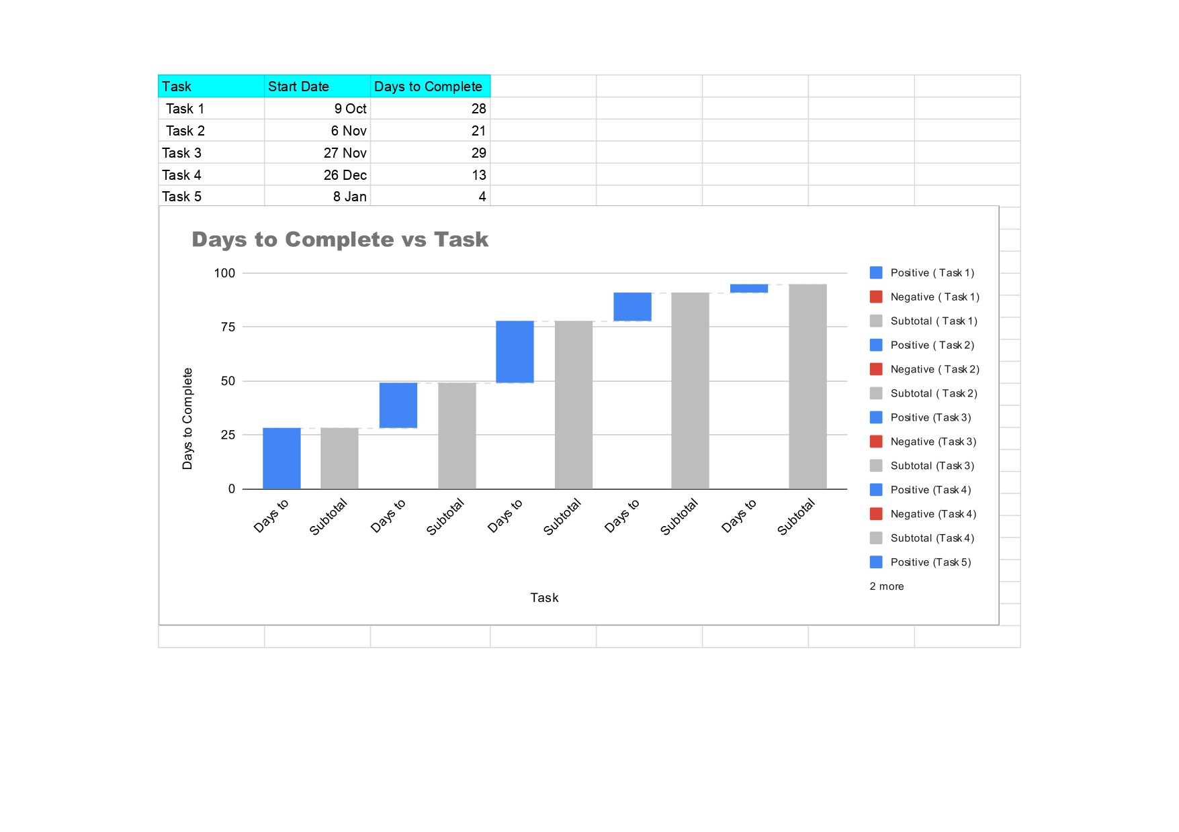

**Table 1:Timeline for execution of project(Gantt Chart)**

**CHAPTER-8**

**OUTCOMES**

**1. Enhanced User Engagement:**

Essentially, a more organic and captivating user experience will result from the integration of NLP, machine learning, and multimodal features.

**Measures:**

Track the proportion of users who come back for more than one interaction to determine user retention.

**Session Duration:** Determine how long people spend in chat sessions on average.

**2. Better Response Quality:**

The quality and relevancy of chatbot responses will be enhanced by machine learning models and natural language processing techniques.

**Measures:**

**Surveys of User Satisfaction:**

To get firsthand input on the perceived caliber of responses, administer surveys.

**Response Coherence:** Using language models and user input, assess the coherence of the responses.several iterations.

Give instances of how improvements have been directly impacted by user feedback.

**3. Effective Resolution of Query:**

**Description:** Quicker and more precise inquiry resolutions will come from the chatbot's integration with external APIs.

**Metrics:** Query Response Time: Calculate how long it takes to process and answer customer inquiries.

**Accuracy of Information:** Assess the accuracy of the data submitted in the answers.

**4. Learning and Adaptability:**

**Description:** Based on user interactions, the chatbot will be able to adapt and get better over time thanks to continuous learning techniques.

**Metrics:** Model Update Frequency: Monitor the frequency at which the model is updated in light of fresh data.

**Response Evolution Analysis:** Examine how responses change between iterations of the model.

**5. Privacy and Ethical Compliance:**

**Summary:** Adhering to ethical principles and putting privacy safeguards in place would guarantee user confidence and adherence to data protection laws.

**Metrics:** Privacy Compliance Audits: Make sure privacy standards are being followed by conducting audits on a regular basis.

**User Trust Surveys:** Learn how users feel about the chatbot's perceived level of trustworthiness.

**6. Reduction of Bias:**

The implementation of strategies aimed at identifying and eliminating biases is expected to yield impartial and equitable interactions with users.

**Metrics:** Bias Identification Rates: Monitor how quickly biases are found and corrected.

**User Input Regarding Bias:**

Get user input on issues with bias in particular.

**7. Efficient User Education:**

**Synopsis:** Through user education programs, users will gain a comprehensive awareness of the chatbot's features and data processing procedures.

**Metrics:** User Interaction Understanding: Use surveys to gauge how well users comprehend the capabilities of the chatbot.

**Reduction in misunderstandings:** Utilize user input to monitor the decline in prevalent user misunderstandings.

**8. Performance and Scalability:**

The system architecture design aims to provide optimal performance for real-time interactions and scalability to accommodate an increasing user population.

**Measures:**

**Handling System Load:**

Assess the system's ability to manage an increase in the number of users at once.

**Latency and Response Time:** Use metrics like these to keep an eye on how responsive your system is.

**9. Multichannel Accessibility:**

Described as follows: Multimodal features allow users to communicate via text, images, and voice among other channels.

**Metrics:**

**Distribution of User Interactions Across Channels:** Monitor how users are interacting with various channels of communication.

**User Preference Surveys:** Learn about the preferences of users for various forms of engagement.

**CHAPTER-9**

**RESULTS AND DISCUSSIONS**

**1. User Engagement and Interaction:**

**Outcomes:**

Examine indicators related to user engagement, such as the length of sessions, frequency of interactions, and survey responses. Talk about the findings by analyzing them to identify trends in user involvement. Talk about how the features and design of the chatbot promote in-depth and meaningful interactions.

**2. Relevance and Quality of Response:**

**Findings:**Share the results of response coherence analysis, user satisfaction surveys, and comments on the caliber of the responses. Examine the variables that affect answer quality, such as the efficiency of machine learning and NLP models. Talk about the enhancements implemented in response to user input.

**3. Effectiveness in Resolving Queries:**

**Outcomes:**Present information on query response times and information correctness.

Talk about how integrating with external APIs makes query resolutions quicker and more precise.

**4. Flexibility and Acquiring Proficiency:**

**Findings:**

Provide information about the model's update frequency and response evolution analysis.Also about how the chatbot changes its responses over time and adjusts to new data.

Give examples of how ongoing education has resulted in significant advancements.  
  
  
**5. Ethical Compliance and Privacy:**

**Outcomes:**Results of user trust surveys and privacy compliance audits should be shared.

Talk about the steps taken to guarantee responsible data management and adherence to privacy laws. Describe the difficulties encountered in preserving user privacy and trust.

**CHAPTER-10**

**CONCLUSION**

One innovative approach that closes important communication gaps between the public and the government is the Government Schemes Chatbot initiative. Our novel methodology was made possible by a thorough examination of the research gaps that already exist, which highlighted the need for a more participatory and user-centric approach.

A dynamic and user-friendly conversational interface has been produced by our seamless integration of speech synthesis and natural language processing technology. The NLTK, HTML, and Flask-based technological framework guarantees scalability and modularity, while the dark theme improves user experience. The project integrates privacy compliance and bias reduction measures while prioritizing ethical considerations, quick responses, and user clarity.   
The iterative development method emphasizes adaptation to changing user needs by incorporating user feedback with a view toward continual improvement. In addition to showcasing concrete project accomplishments, results and discussions offer insightful information about user participation, response quality, and overall effectiveness.

This revolutionary trip not only tackles the difficulties encountered but also acts as a lighthouse for the revolutionary potential of AI in improving public services. In conclusion, the Government Schemes Chatbot is not only a technological marvel but also evidence of the continuous dedication to creativity, cooperation, and quality in the field of public services.  
In addition, the integration of sophisticated machine learning models, enabled by scikit-learn and numpy, endows the chatbot with a continuously improving capacity to interpret user inquiries. A large dataset and a thorough approach to investigate gaps support the chatbot's resilience in delivering precise and context-aware responses. This project sets a standard for the incorporation of AI in public services in addition to making a contribution to the field of conversational agents. Using a dark theme shows a dedication to accessibility and inclusivity in addition to improving visual appeal. The intended results are in line with the larger digital transformation programs and promote citizens who are better educated, involved, and empowered. The foundation of this project is the symbiotic relationship between technological innovation and improved public services.

**REFERENCES**

1. RNN or Recurrent Neural Network for Noobs – RNN Architecture <https://hackernoon.com/rnn-or-recurrent-neural-network-fornoobs-a9afbb00e860>
2. Divya Madhu, Neeraj Jain C.J, Elmy Sebastain, Shinoy Shaji and Anandhu Ajayakumar, “A Novel Approach for Medical Assistance Using Trained Chatbot”,International Conference on Inventive Communication and Computational Technologies(ICICCT 2017).
3. AM Rahman, Abdullah Al Mamun, Alma Islam, “Programming challenges of Chatbot: Current and Future Prospective”, 2017 IEEE Region 10 Humanitarian Technology Conference (R10-HTC)21 - 23 Dec 2017, Dhaka, Bangladesh.
4. Shafquat Hussain , Prof. Athula Ginige, “Extending a conventional chatbot knowledge base to external knowledge sources and introducing user based sessions for diabetes education”, 2018 32nd International Conference on Advanced Information Networking and Applications Workshops.
5. Lisa N.Michaud, “Observations of a new chatbot – Drawing conclusions from early interactions with users”, Feature Article: Virtual Assistant Chatbots, published by IEEE Computer Society 2018.
6. Rupesh Singh, Harshkumar Patel, Manmath Paste, Nitin Mishra, Nirmala Shinde, “Chatbot using TensorFlow for small Businesses”, 2nd International Conference on Inventive Communication and Computational Technologies (ICICCT 2018)
7. Nielsen Norman Group “The user experience of chatbot” <https://www.nngroup.com/articles/chatbots/> .
8. Training a model <https://pythonprogramming.net/chatbot-deep-learningpython-tensorflow/>.
9. Verify that the training is in progress and it goes correctly <https://blog.kovalevskyi.com/rnn-based-chatbot-for-6-hoursb847d2d92c43>
10. Pure Python vs NumPy vs TensorFlow Performance Comparison [Pure Python vs NumPy vs TensorFlow Performance Comparison – Real Python](https://realpython.com/numpy-tensorflow-performance/) .
11. The Influence of AI-Based Chatbots and Their Design on Users Trust and Information Sharing in Online Loan Applications  
    <https://www.researchgate.net/publication/348236025_The_Influence_of_AI-Based_Chatbots_and_Their_Design_on_Users_Trust_and_Information_Sharing_in_Online_Loan_Applications>.

**APPENDIX-A**

**PSEUDOCODE**

**RUN.py**

# Import necessary modules

import os

import json

import numpy as np

import pickle

from time import sleep

from sklearn.linear_model import LogisticRegression

from nltk_utils import tokenize, stem, bag_of_words

# Set the current directory to the directory of the script

directory = __file__[:-len('run.py')]

os.chdir(directory)

# Execute the training script

os.system('cmd /c "python train.py"')

# Execute the API script

os.system('cmd /c "python api.py"')

**TRAIN.PY**

# The train.py script

# Load intents from JSON file

with open("intents.json", "r") as f:

intents = json.load(f)

# Initialize lists

tags = []

all_words = []

df = []

# Extract tags and patterns from intents

for intent in intents['intents']:

tag = intent['tag']

tags.append(tag)

for pattern in intent['patterns']:

# Tokenize and stem the words

w = tokenize(pattern)

all_words.extend(w)

df.append([w, tag])

# Preprocess the words (remove punctuation, etc.)

ignore_list = ["?", "!", ".", ","]

all_words = [stem(w) for w in all_words if w not in ignore_list]

# Sort and make unique word list and tag list

all_words = sorted(set(all_words))

tags = sorted(set(tags))

# Prepare training data

X_train = []

y_train = []

# Create bag of words for each patterned sentence

for (patterned_sentence, tag) in df:

bag = bag_of_words(patterned_sentence, all_words)

X_train.append(bag)

y_train.append(tag)

# Convert lists to numpy arrays

X_train = np.array(X_train)

y_train = np.array(y_train)

# Create and train the model

model = LogisticRegression()

model.fit(X_train, y_train)

# Print a success message

print("Model Trained Successfully......")

# Save the model and word list to files

if not os.path.exists('models'):

os.makedirs('models')

if not os.path.exists('wordlist'):

os.makedirs('wordlist')

pickle.dump(model, open("models/Model V1.pkl", "wb"))

pickle.dump(all_words, open('wordlist/words.pkl', 'wb'))

**NLTK .PY**

# Import necessary modules

import nltk

import numpy as np

from nltk.stem.porter import PorterStemmer

# Download the NLTK punkt tokenizer if not already downloaded

nltk.download('punkt')

# Tokenize a sentence into words

function tokenize(sentence):

return nltk.word_tokenize(sentence)

# Stem a word using the Porter stemmer

function stem(word):

stemmer = PorterStemmer()

return stemmer.stem(word).lower()

# Create a bag of words representation for a tokenized sentence

function bag_of_words(tokenized_sentence, all_words):

# Initialize a bag of zeros with the length of all_words

bag = np.zeros(len(all_words))

# Stem the words in the tokenized sentence

stemmed_words = [stem(word) for word in tokenized_sentence]

# Iterate over each word in all_words and update the bag

for index, word in enumerate(all_words):

if word in stemmed_words:

bag[index] += 1

return bag

**API. Py**

# Import necessary modules

import flask

from chat import bot_response

from flask import Flask, render_template, request

import webbrowser

from datetime import datetime

# Initialize the Flask app

app = Flask(__name__, template_folder="./")

app.static_folder = 'static'

# Get the current time

now = datetime.now()

current_time = now.strftime("%H:%M")

# Define routes and corresponding functions

@app.route("/dark")

def chat():

return render_template("dark theme.html", time=current_time)

@app.route("/index")

def index():

return render_template("index.html", time=current_time)

@app.route("/")

def home():

return render_template("home.html", tym=current_time)

@app.route("/login1")

def login1():

return render_template("login1.html", tym=current_time)

@app.route("/get")

def get_bot_response():

# Get the user input from the request arguments

userText = request.args.get('msg')

# Get the bot's response using the bot_response function

answer = str(bot_response(userText))

# Return the bot's response

return answer

# Start the Flask app

if __name__ == "__main__":

# Open the web browser to the app's URL

webbrowser.open('http://localhost:5000')

# Run the app on localhost

app.run(host='localhost')

**CHAT.PY**

# Import necessary modules and functions

import random

import json

import pickle

from nltk_utils import tokenize, stem, bag_of_words

# Load intents from JSON file

with open("intents.json", "r") as f:

intents = json.load(f)

# Load the pre-trained model and word list from pickle files

modelone = pickle.load(open("models/Model V1.pkl", "rb"))

all_words = pickle.load(open("wordlist/words.pkl", "rb"))

# Define the bot_response function

function bot_response(input):

# Create bag of words features for the input using the loaded word list

features = bag_of_words(tokenize(input), all_words)

# Use the model to predict the tag for the input

tag = modelone.predict([features])[0] # Use [0] to get the first element of the array

# Iterate through intents to find a matching tag

for intent in intents['intents']:

if tag == intent['tag']:

# If a matching tag is found, randomly select and return a response

output = random.choice(intent['responses'])

return output # Return the response if it matches the main tag

# If no matching tag is found, return a default response

return "I'm sorry, I'm not sure how to respond to that."

**INDEX. HTML**

// Import necessary modules

import nltk

import numpy as np

from nltk.stem.porter import PorterStemmer

nltk.download('punkt')

// Define a function to tokenize a sentence

function tokenize(sentence):

return nltk.word_tokenize(sentence)

// Define a function to stem a word

function stem(word):

stemmer = PorterStemmer()

return stemmer.stem(word).lower()

// Define a function to create a bag of words representation for a tokenized sentence

function bag_of_words(tokenized_sentence, all_words):

bag = np.zeros(len(all_words))

stemmed_words = [stem(word) for word in tokenized_sentence]

for index, word in enumerate(all_words):

if word in stemmed_words:

bag[index] += 1

return bag

// Define the structure of the HTML page

<body bgcolor="5b5b5b">

<section class="msger">

<header class="msger-header">

<div class="msger-header-title">

<p class="headingtitle">G-Bot(Gov_Info_Bot)</p>

</div>

</header>

<main class="msger-chat">

<!-- Messages go here -->

</main>

<form class="msger-inputarea">

<input type="text" class="msger-input" id="textInput" placeholder="Enter your message...">

<button type="submit" class="mic-button" id="startDictation"></button>

<button type="submit" class="msger-send-btn">Send</button>

<button type="button" class="mute-button" id="muteUnmuteButton">Mute</button>

</form>

</section>

<script src='https://use.fontawesome.com/releases/v5.0.13/js/all.js'></script>

<script>

// JavaScript code for speech recognition, form submission, and bot responses

</script>

</body>

// JavaScript code for the chat functionality

const msgerForm = get(".msger-inputarea");

const msgerInput = get(".msger-input");

const msgerChat = get(".msger-chat");

// Event listener for form submission

msgerForm.addEventListener("submit", event => {

event.preventDefault();

const msgText = msgerInput.value;

if (!msgText) return;

appendMessage(PERSON_NAME, PERSON_IMG, "right", msgText);

msgerInput.value = "";

botResponse(msgText);

});

// Function to append a message to the chat

function appendMessage(name, img, side, text) {

const msgHTML = `

<div class="msg ${side}-msg">

<div class="msg-img" style="background-image: url(${img})"></div>

<div class="msg-bubble">

<div class="msg-info">

<div class="msg-info-name">${name}</div>

<div class="msg-info-time">${formatDate(new Date())}</div>

</div>

<div class="msg-text">${text}</div>

</div>

</div>`;

msgerChat.insertAdjacentHTML("beforeend", msgHTML);

msgerChat.scrollTop += 500;

}

// Function to handle bot responses

function botResponse(rawText) {

// Bot Response

$.get("/get", { msg: rawText }).done(function (data) {

console.log(rawText);

console.log(data);

const msgText = data;

appendMessage(BOT_NAME, BOT_IMG, "left", msgText);

let speech = new SpeechSynthesisUtterance();

let synth = window.speechSynthesis;

speech.lang = "en-UK";

speech.text = msgText;

speech.volume = 2;

speech.rate = 1;

speech.pitch = 1;

synth.speak(speech);

});

}

// Mute/Unmute button event listener

document.getElementById("muteUnmuteButton").addEventListener("click", function() {

if (isMuted) {

isMuted = false;

if (pausedUtterance !== null) {

window.speechSynthesis.resume();

} else {

window.speechSynthesis.speak(speech);

}

this.textContent = "Mute";

} else {

isMuted = true;

if (window.speechSynthesis.speaking) {

window.speechSynthesis.pause();

pausedUtterance = speech;

}

this.textContent = "Unmute";

}

});

// Utility function to get an element by selector

function get(selector, root = document) {

return root.querySelector(selector);

}

// Utility function to format a date

function formatDate(date) {

const h = "0" + date.getHours();

const m = "0" + date.getMinutes();

return `${h.slice(-2)}:${m.slice(-2)}`;

}

**APPENDIX-B**

**SCREENSHOTS**

1. **Home Page:**

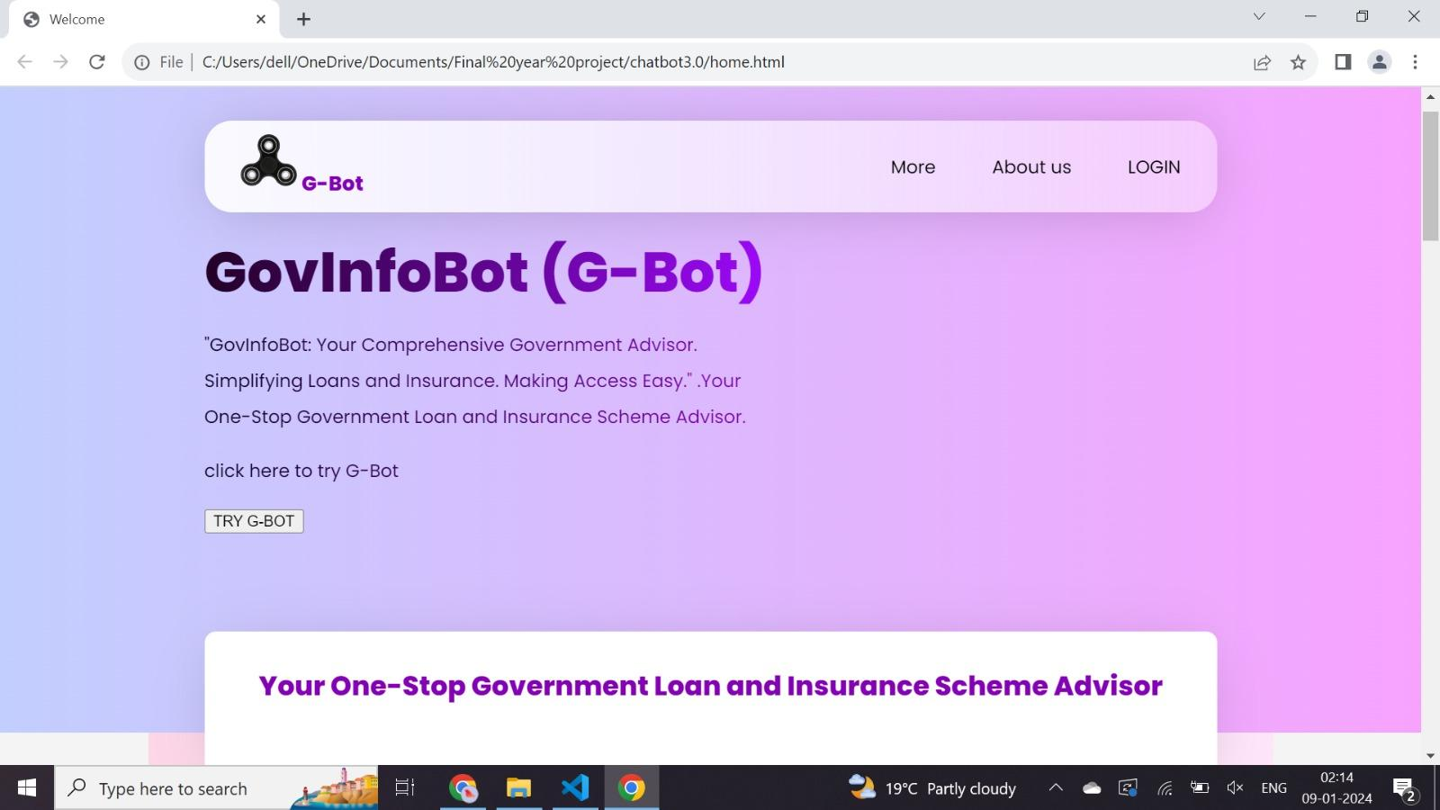

1. **Login page:**

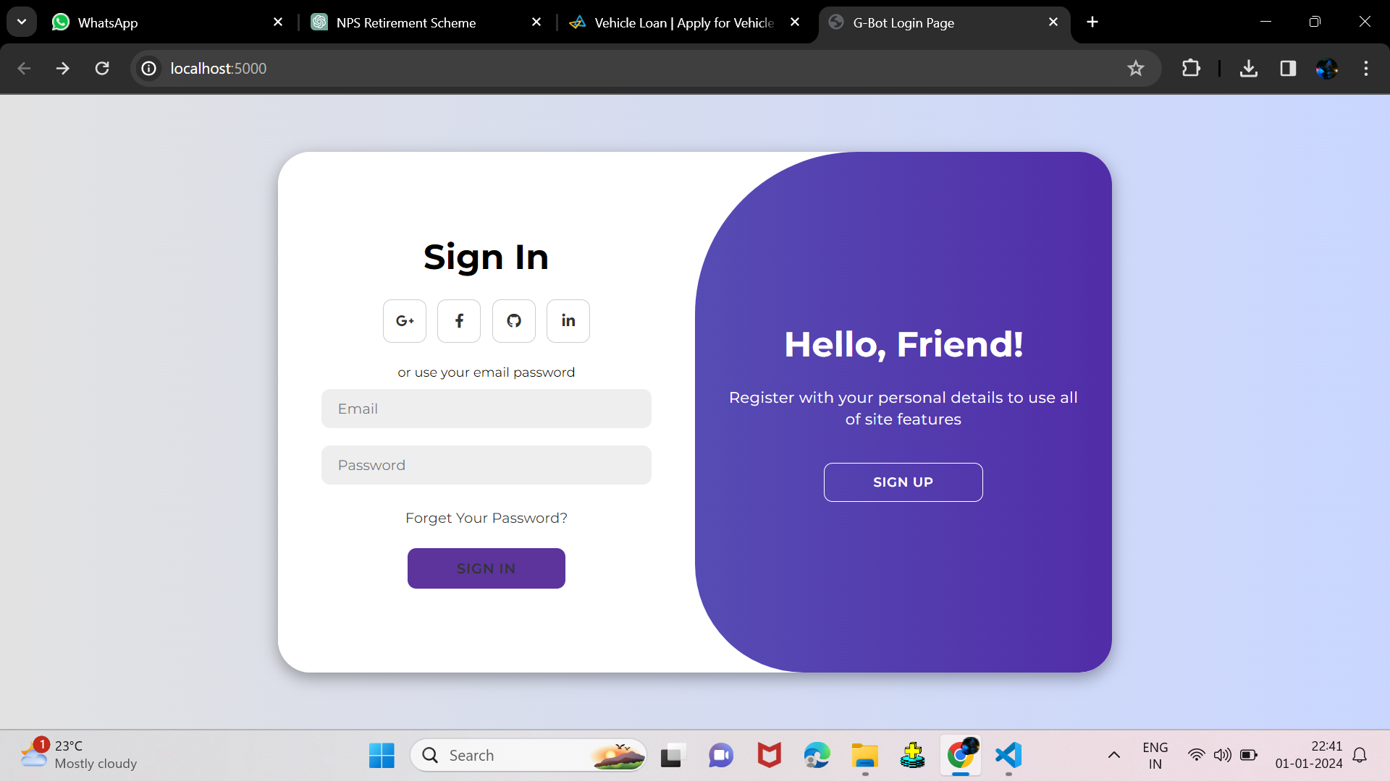

1. **Govt_Info_Bot in LIGHT Theme.  
     
   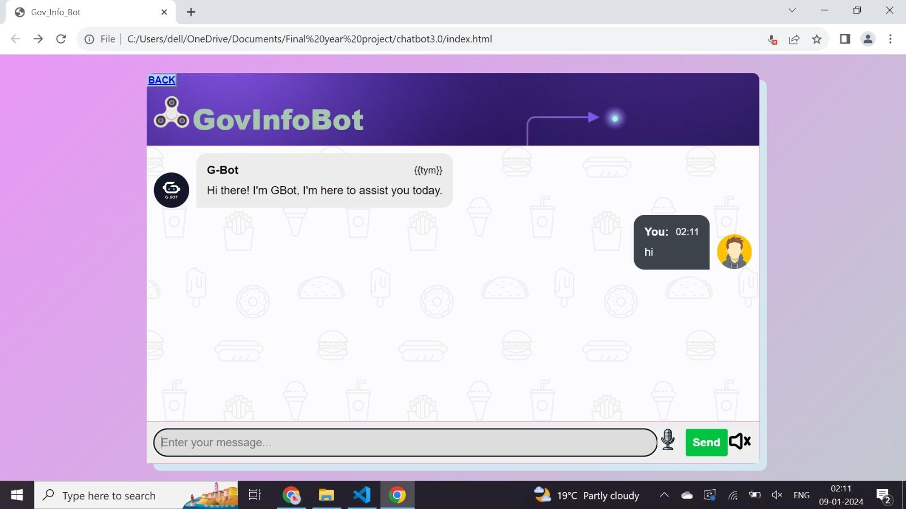**
2. **Govt_Info_Bot in DARK Theme:**

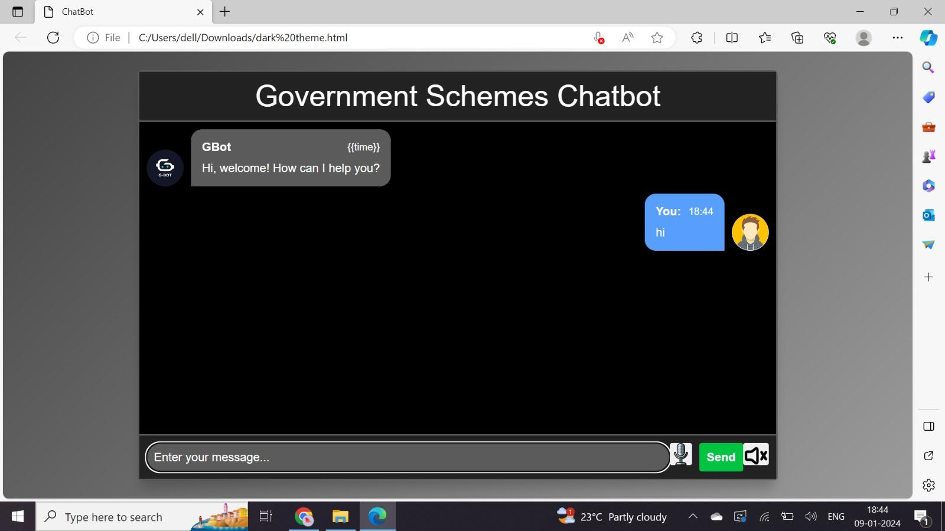

**APPENDIX-C**

**ENCLOSURES**

**CERTIFICATES:**









